Name:

ID:

M2 Assignment C1-03 V2

Part 1:

1. Create the following using HTML, CSS, and JavaScript. When you hover over each element in the table, the background color should change to cyan. The names should be colored red and be bold. The countries should be colored orange and italicized:



1. Create the following using HTML, CSS, and JavaScript. The darkcyan box is twice as big as the lightblue box and the lightblue box is twice as big as the blue box:



1. Create the following with HTML, CSS, and JavaScript. When you click on each box, the background color of the web page should change to the color written on the box:

Before click:

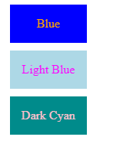

After clicking on each color:

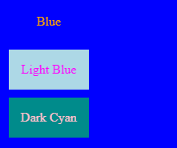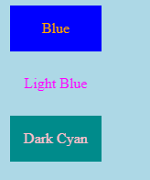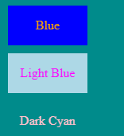

1. Use HTML, CSS, and Javascript to create the following. Whatever the user types in the text input box should be displayed in an h2 element above the text-input:

Before:



After:

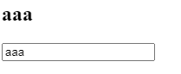

1. Recreate the following using HTML, CSS, and Javascript. The websites should be hyperlinks (HTML <a> tags) that lead to a website. The images can be anything that you find interesting (school appropriate).

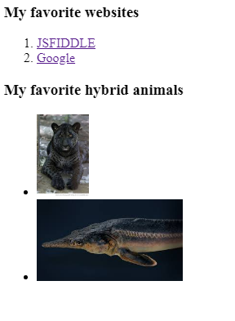

Part 2:

1. Which of the following HTML tags is a web page within a webpage:

|  |  |
| --- | --- |
| audio | webpage |
| iframe | internet |
| frame | Editor |
| browser | javascript |

1. Which of the following makes comments for Javascript:

|  |  |
| --- | --- |
| <!-- ->  /**/ | <!-- -> |
| # | //  /**/ |
| “”” “”” | “”” “””  # |
| “” | -> |

1. Which of the following is not an HTML input type:

|  |  |
| --- | --- |
| text | email |
| password | date |
| checkbox | tel |
| file | id |

1. Which of the following generates an error:

|  |  |
| --- | --- |
| const PI = 3.141592653589793;  PI = 3.14; | let PI = 3.141592653589793;  PI = 3.14; |
| var PI = 3.141592653589793;  PI = 3.14; | const PI = 3.141592653589793; |
| let PI = 3.141592653589793; | var PI = 3.141592653589793; |

1. Which of the following generates a random integer in javascript:

|  |  |
| --- | --- |
| Math.integer() | ˜ ˜(Math.random() * 1000) |
| parseInt(Random()) | Math.random() |
| Math.random() * 1000 | Randint() |
| Integer() | Random integer() |